**Retention Pond Planning for Flood Management**

**Using Epa SWMM in Sayung Village**

**Demak Regency**

Ari Sentani1* and M. Faiqun Niam2

*1**UNISSULA, Jl. Raya Kaligawe Km.04, Semarang, 50112, Indonesia*

*2 UNISSULA, Jl. Raya Kaligawe Km.04, Semarang, 50112, Indonesia*

* *Corresponding author:* *Ari Sentani*

(**Received:** Month Year ; **Revised:** Month Year ; **Accepted:** Month Year)

**Abstract:** The area of Sayung Village, Sayung District, and Demak Regency is an area that is often hit by annual floods. According to the Sayung Village Government, floods in 2019 resulted in 5,884 residents of Sayung Village being displaced and 1,471 houses being flooded. The area of submerged rice fields is 300 hectares, with the number of farmers who failed to harvest reaching 436. Comprehensive handling is needed to deal with the flood. For flood management, a simulation of a flood management system was made with EPA SWMM (Environmental Protection Agency Storm Water Management Model) software. The selection of handling concepts is obtained through re-simulation of the capacity of drainage channels in order to accommodate planned discharge. To be able to perform simulations, hydrological data and measurements of existing channels are needed. Flood discharge obtained from the calculation results is Q2 of 110.1 m3 per second, Q5 of 134.9 m3 per second, and Q10 of 147.8 m3 per second. The handling concept obtained from this study is the creation of retention ponds in Dukuh Sayung Kidul and Dukuh Sayung Wetan.

**Keywords:** *Flood, Discharge, Retention Pond, EPA SWMM*

1. **Introduction**

Flooding is a natural phenomenon that usually occurs in an area that is watered by many rivers, the area of Sayung Village, Sayung District, Demak Regency is an area that is often hit by annual floods, according to the Sayung Village Government in 2019 floods resulted in 5,884 residents of Sayung Village being displaced and 1,471 houses flooded. The area of submerged rice fields is 300 hectares with the number of farmers who failed to harvest reaching 436 people.

According to Subardjo [1] the Sayung Coastal area is a lowland with a relatively flat topography of less than 2%, elevation 0-5 meters above sea level, besides that there are also jointations in the Dombo Sayung River and drainage channels of Sayung Village resulting in water easily overflowing to residential areas. This is the main cause of the 2019 Sayung Village flood. So research is needed to be able to plan drainage systems that can reduce the impact of flooding or can overcome it.

To analyze the capacity of the existing drainage system in accommodating rain discharge, simulations were used with EPA SWMM (Environmental Protection Agency Storm Water Management Model) software. The selection of handling concepts is obtained through re-simulation of the capacity of drainage channels in order to accommodate planned discharge. To be able to perform simulations, hydrological data and measurements of existing channels are needed.

EPA SWMM modeling has been used in various countries including Indonesia. Some previous studies that were used as references in this study are: Lei Jiang et al [2] who conducted research entitled Urban Flood Simulation Based on the SWMM Model; Situmorang, R [3] applied the EPA SWMM 5.1 model for the evaluation of drainage channels at Darmawangsa Residence, Bekasi, West Java; Wirosoedarmo, R et al [4] modeled a drainage system with EPA SWMM application in Sawojajar Housing Malang City; Syuhada, R.A et al [5] with the research title Flood Discharge Analysis using EPA Storm Water Management Model (SWMM) in Kampar Kiri Sub Watershed (Case Study: Folding Kain Village, Kampar Kiri); Augusta, N [6] who conducted research on the evaluation of drainage channels using the swmm 5.1 program at Villa Ratu Endah Housing, Bogor, West Java; Hudhiyantoro [7] conducted a research on the Potential Application of Ecodrainage in Sumberejo Village, Pakal District, Surabaya City using EPA SWMM 5.1 as a model. The study took a slightly different position to previous research by focusing on rural areas prone to flooding. So that the right model can be obtained in handling floods in rural areas.

1. **Literature Review**
   1. **EPA SWMM**

EPA SWMM (Environmental Protection Agency Storm Water Management Model) is a dynamic rainfall-runoff simulation model used for single event or long-term (continuous) simulation of runoff quantity and quality from primarily urban areas [8]. This software is able to simulate the influence of rain runoff from an area on its drainage system in the short and long term while having alternative facilities to anticipate flood problems. The EPA SWMM has been widely used for modeling water quantity and quality in urban areas in various countries.

Modeling in EPA SWMM has been used for complex hydraulic analysis of sewer problems, drainage network management, and the study of various pollution problems. Dimensional planning of exhaust networks for flood control as well as planning of temporary containment areas for flood control and mapping of flood inundation areas can be analyzed and simulated using EPA SWMM model applications. This model can be used to calculate various hydrological processes by considering runoff from urban areas, namely rainfall with time variations, water surface evaporation, snow accumulation and melting, rainfall in reservoir areas, infiltration from rainfall entering the soil layer that is not saturated with water, percolation and infiltration into the groundwater layer, bottom flow between groundwater, and drainage systems.

## The EPA SWMM’s runoff component functions as a collection of sub-catchment areas that receive precipitation and generate runoff and pollutants. Pipes, channels, storage or treatment facilities, pumps, orifices, weirs, and outlets can all be used to channel runoff. It is a complete dynamic wave simulation model that is used to simulate runoff quantity and quality from metropolitan areas, either for a single event or over an extended period. It is a tool that offers a setting for visualizing the outcomes of hydrologic simulations.

## Figure 1 [8] illustrates how the physical components of the actual system are conceptualized by SWMM. Rain Gages and Sub Catchments are the main modeling components for the rainfall/runoff process. Aquifer objects are used to simulate groundwater flow, whereas Snowpack objects are used to depict snowmelt when put on top of sub catchments. A network of Nodes and Links is used to model the conveyance element of the drainage system. Nodes are points that stand in for straightforward junctions, flow dividers, storage compartments, or outfalls. Conduits (pipes and channels), pumps, or flow regulators are used by links to connect nodes to one another (orifices, weirs, or outlets). Water quality is described using the terms Land Use and Pollutant.Finally, a group of data objects that includes Curves, Time Series, Time Patterns, and Control Rules, are used to characterize the inflows and operating behavior of the various physical objects in a SWMM model.

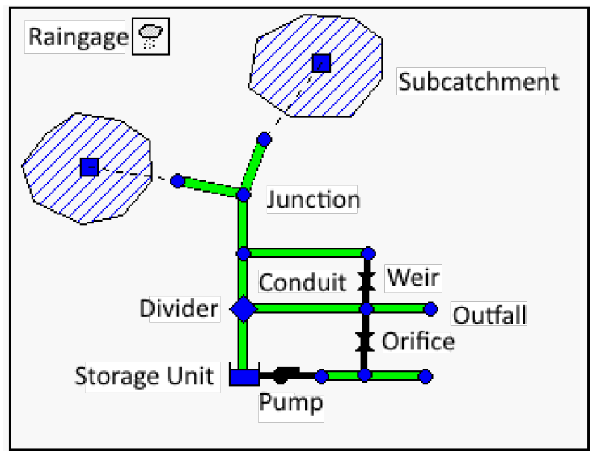

**Fig. 1.** SWMM's conceptual model of a stormwater drainage system.

* 1. **Frequency Analysis**

## The frequency of rain is the probability of a magnitude of rain being equaled or exceeded. A return period is a hypothetical time in which rain of a certain magnitude will be equaled or exceeded [9]. The purpose of frequency analysis of hydrological data is to determine the magnitude of extreme events related to their frequency of occurrence through the application of possible distributions. The hydrological data analyzed are assumed to be independent, randomly distributed, and stochastic [9].

## The frequency with which specific rainfall amounts or depths are anticipated to occur is calculated using a rainfall frequency analysis. The rainfall depth associated with a specific likelihood of exceedance can also be quantified using the data from the rainfall frequency analysis. Therefore, knowledge of the design values (quantiles) of excessive one-day and multi-day rainfall quantities is essential in several water resources engineering fields, such as dam and sewage system design, flood mitigation, and protection against soil and vegetation loss [10].

* 1. **Rain Intensity Analysis**

The intensity of rain is the height or depth of water per unit time. The general nature of rain intensity is that the shorter the rain, the higher the intensity and the greater the recurrence period, the higher the intensity.

The rainfall intensity–duration–frequency (IDF) curves are graphical representations of the probability that a given average rainfall intensity will occur within a given period of time [11]. To obtain IDF graphs from daily rainfall data is done using the Mononobe method. This equation is used when short-term rain data is not available, only daily rain data is available. To convert rainfall depth into rainfall intensity, the formula needs information about the period of concentration (I).

$I=\frac{R_{24}}{24}{\left(\frac{24}{t}\right)}^{\frac{2}{3}}$ (1)

for:

I : rainfall intensity (mm/hour)

R 24 : maximum daily rainfall at certain return period (mm)

T : time of concentration (hour)

1. **Research Methods**
   1. **Research Location**

## The location of this research is in Sayung sub-district, Demak regency with an area of 510,046 km2. Sayung Village is located in a lowland located at an altitude of 1 meter above sea level with coordinate -6.944341328736436, 110.51174335205845. Sayung Village consists of 8 hamlets including: Sayung Wetan, Sayung Lor, Sayung Kidul, Sayung Kulon, Babadan, Ngepreh, Lengkong, and Ngablaksari which are divided into 8 RWs (Rukun Warga) and into 36 RTs (Rukun Warga). It will concentrate on Dukuh Sayung Kidul and Dukuh Sayung Wetan for this research.

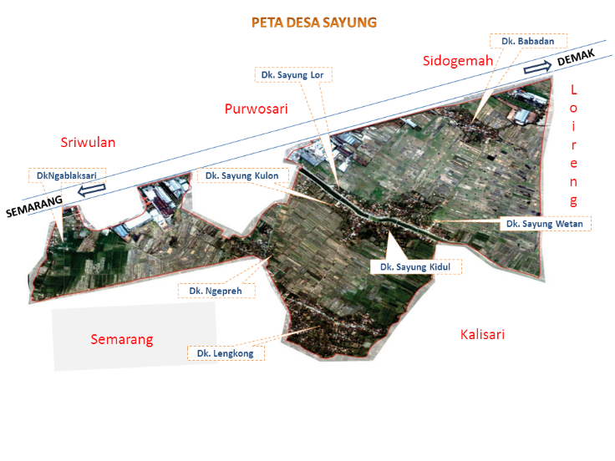

**Fig. 2.** Research Location

* 1. **Research Procedure**

## The data collection method used in this study is a direct observation method to obtain primary data and collect data from related documents. After the data is collected, data processing is carried out using EPA SWMM software. The completion methodology in this study is as depicted in the flow chart. Literature studies are conducted to obtain the theoretical foundations and research steps related to EPA SWMM modeling from books, websites, or journals. The data needed in this study includes rainfall data. The rainfall data used is the maximum daily rainfall data for 2008–2019 obtained from the Meteorology, Climatology, and Geophysics Agency (BMKG). The stages of data processing and analysis are as follows:

## Hydrological analysis is carried out using the following stages:

## Determining the analysis of maximum daily rainfall by statistical distribution,

## Conduct distribution suitability tests,

## Perform a high distribution of hourly rainfall with the Mononobe formula, which will be compared with the Nakayasu method.

## Analyze the area of sub-areas and land use classifications from land use maps cultivated using GIS-based programs.

## Analyze planned flood discharges using the EPA SWMM program.

## Planning flood management in the form of creating retention ponds using EPA SWMM Analysis of rain intensity.

* 1. **Research Flowchart**

The stages of research are broadly contained in the research flow chart, as shown in figure 2 below.

**Fig. 3.** Flow Chart of Research

1. **Results And Discussion**
   1. **Hydrological Analysis**

Analysis is needed to be able to determine the design flood discharge using monthly rainfall data from two rain stations, namely Banyumeneng (99) and Pucanggading (98).

**Table 1**. Average maximum daily rainfall

|  |  |  |  |
| --- | --- | --- | --- |
| Year | Station 98 | Station 99 | X=S(X1-2) |
| 2009 | 150 | 160 | 155 |
| 2010 | 87 | 85 | 86 |
| 2011 | 150 | 150 | 150 |
| 2012 | 100 | 61 | 80,5 |
| 2013 | 90 | 147 | 118,5 |
| 2014 | 106 | 175 | 140,5 |
| 2015 | 105 | 122 | 113,5 |
| 2016 | 104 | 215 | 159,5 |
| 2017 | 82 | 165 | 123,5 |
| 2018 | 88 | 95 | 91,5 |

Based on the table above, it is then calculated based on the probability distribution, and the smallest deviation of the data is obtained using the normal method. So, the design rainfall data was used to use the normal method, as shown in the table below.

**Table 2.** Results of Design Rainfall

|  |  |
| --- | --- |
| Return Periods (years) | Design Rainfall (mm) |
| 2 | 110,1 |
| 5 | 134,9 |
| 10 | 147,8 |
| 20 | 158,5 |
| 25 | 161,6 |
| 50 | 170,6 |
| 100 | 178,6 |

Drainage system planning requires estimating peak discharge in small catchment areas by analyzing IDF graphs or the relationship between rain intensity, duration, and frequency. To obtain the IDF graph from daily rainfall data, use the Mononobe formula. The results of the calculation of rain intensity can be seen in the following table:

**Table 3.** Rain Intensity Calculation

|  |  |  |  |  |
| --- | --- | --- | --- | --- |
| Duration | | Intensity | | |
| **2 years** | **5 years** | **10 years** |
| Minutes | **Hours** | 110,1 | 134,9 | 147,8 |
| 15 | 0,25 | 96,18 | 117,85 | 129,12 |
| 30 | 0,5 | 60,59 | 74,24 | 81,34 |
| 45 | 0,75 | 46,24 | 56,65 | 62,07 |
| 60 | 1 | 38,17 | 46,77 | 51,24 |
| 120 | 2 | 24,05 | 29,46 | 32,28 |
| 180 | 3 | 18,35 | 22,48 | 24,63 |
| 240 | 4 | 15,15 | 18,56 | 20,33 |
| 300 | 5 | 13,05 | 15,99 | 17,52 |
| 360 | 6 | 11,56 | 14,16 | 15,52 |

* 1. **EPA SWMM Analysis**

EPA SWMM analysis is used to perform various hydrological and hydraulic analyses, with various options that can be used. The focus of drainage canal arrangements was carried out in Sayung Kidul Hamlet and Sayung Wetan Hamlet because these two hamlets experienced severe flooding. In addition, there is a location that can be used as a retention pond.

From the analysis of Manning roughness data, despression storage data, horton infiltration data, channel data, and rainfall data processed using EPA SWMM, the following results were obtained:

**Table 4.** Dombo Sayung Sub Watershed Data

|  |  |  |  |
| --- | --- | --- | --- |
| Catchment | Area (m2) | Width (m)a | Information |
| 1 | 389 | 14 | **%Slope : 0.5** |
| 2 | 387 | 13 | %Imperv : 25 |
| 3 | 619 | 16 | N-impervb : 0.012 |
| 4 | 616 | 15 | N-pervc : 0.13 |
| 5 | 546 | 16 | D-impervd : 0.05 |
| 6 | 964 | 25 | D-perve : 0.15 |
| 7 | 398 | 12 |  |
| 8 | 354 | 13 |  |
| 9 | 1265 | 30 |  |
| 10 | 354 | 12 |  |
| 11 | 543 | 18 |  |
| 12 | 276 | 16 |  |
| 13 | 365 | 10 |  |
| 14 | 342 | 8 |  |

* 1. **EPA SWMM Scheme**

After analyzing the data, drawings or schematics are obtained on the EPA SWMM.

**Fig. 4.** SWMM Scheme of Sayung Village

The scheme is obtained by creating a junction or channel scheme and a retention pond that will be used for flood management.

**Fig. 5.** Junction Scheme and Retention Ponds

* 1. **Data Storage in Retention Ponds**

The paper should be formatted as follows: Retention ponds are planned in two hamlets, namely Dukuh Sayung Wetan and Dukuh Sayung Kidul. The planning for both ponds is the same : area of 25,000 m2 with a depth of 7 m and total capacity of 175,000 m3. The storage curve can be seen in Figure 5.

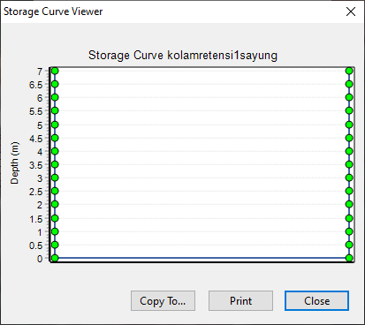

**Fig. 6.** Storage Curve

1. **Conclusions**

The conclusions obtained from this study are:

1. The planned flood discharge obtained was Q2 of 110.1 m3 / second, Q5 of 134.9 m3 / second and Q10 of 147.8 m3 / second.
2. The volume of the Retention Ponds used to deal with flooding in Sayung Village is 175,000 m3 for the Ponds in Sayung Kidul Hamlet and 175,000 m3 for the Ponds in Sayung Wetan Hamlet.
3. Flood management must be carried out thoroughly and simultaneously so that comprehensive handling is obtained.

**Acknowledgements**

This research was fully supported by LPPM UNISSULA. We thank our colleagues from UNISSULA and the Sayung Government, who provided insight and expertise that greatly assisted the research.

**References**

1. Subardjo P. (2015). Genangan Banjir Pasang Pada Kawasan Pemukiman di Kecamatan Sayung Kabupaten Demak. *FPIK Universitas Diponegoro, Semarang.*
2. Lei Jiang et al. (2014). Urban Flood Simulation Based on the SWMM Model., *Proceedings RSHS14 and ICGRHWE14*, Guangzhou, China, August 2014, p. 186-191.
3. Situmorang, R. (2015), Penerapan Model Epa Swmm 5.1 Untuk Evaluasi Saluran Drainase Di Darmawangsa Residence, Bekasi, Jawa Barat. *Institut Pertanian Bogor, Bogor.*
4. Wirosoedarmo, R et al. (2017). Performance Evaluation of Settlement Drainage Channels Using EPA Swmm 5.1 Software (Case Study of Sawojajar Housing Malang City. Indonesia). *Proceedings of FKPT-TPI National Seminar 2017, Kendari, p. 246-259.*
5. Syuhada, R.A et al. (2016). Flood Discharge Analysis using EPA Storm Water Management Model (SWMM) in Kampar Kiri Sub Watershed (Case Study: Desa Lipat Kain, Kampar Kiri). *Jom FTEKNIK Volume 3 No.2 October 2016.*
6. Augusta, Nico. (2017). Evaluation of drainage channels using the SWMM 5.1 program in Villa Ratu Endah Housing, Bogor, *West Java.Bogor Agricultural University, Bogor.*
7. Hudhiyantoro et al. (2019). Potensi Penerapan Ecodrainage di Desa Sumberejo Kecamatan Pakal Kota Surabaya, *RekaRacana: Jurnal Teknik Sipil, No.1 Vol. 5, p.10-18.*
8. Lewis A. Rossman and Wayne C. Huber (2016). Storm Water Management Model Reference Manual Volume I – Hydrology (Revised). National Risk Management Laboratory Office of Research and Development U.S. Environmental Protection Agency (EPA).
9. Suripin. (2004). Sustainable Urban Drainage Systems. Yogyakarta : Andi.
10. Gaál, L.; Kyselý, J.; Szolgay, J. (2008). Region-of-influence approach to a frequency analysis of heavy precipitation in Slovakia. Hydrol. Earth Syst. Sci. **(**12) 825–839.
11. Dupont BS and Allen DL. (2000). Revision of the rainfall intensity duration curves for the commonwealth of Kentucky. Kentucky Transportation Centre, College of Engineering, University of Kentucky, Lexington.