Accademic Information Sistem Using Analytical Hierarchy Process Algorithm For Determining Student Over Study
(Justify, Bold, Arial 16, written in English)

First Author¹, Second Author², Third Author³
 | ¹ | Institutions/Affiliations/Departments
 | ² | Institutions/Affiliations/Departments
 | ³ | Institutions/Affiliations/Departments
(Table border will be removed if this paper accepted)

ABSTRACT (Left, Bold, Arial 11 pt, written in English)
Abstract should be written in one paragraph contains background of the research, purpose of the research, algorithm explanation for solving the problem and the statement of problem solutions, the abstract should be not more than 300 word length. Times New Roman, font size 10, in italics, single spacing. No literature should be cited. The keyword used in the abstract may increase the readers to find our article with easy way.

(Left, Italic, Times New Roman 10pt, written inEnglish)

Keywords: First keyword; Second keyword; Third keyword; Fourth keyword; Fifth keyword
corresponding email : firstauthor@mail.com | .
This is an open access article under the CC BY license
(Table border will be removed if this paper accepted)

- INTRODUCTION (TNR, 10 PT)
The purpose of this guide is to produce a paper that conforms to the rules for the paper for the Journal of Applied Science and Technology. Papers are prepared in softcopy format with A4 paper size format. With format of Margin: top = 3 cm, bottom = 2.5 cm, outer side = 2.5 cm, inside = 2.5 cm. Indented paragraph size is 0.35 cm. Citation of the bibliography are made in IEEE style in sign [1, 2]. The manuscript is written in Microsoft Word, single space, Time New Roman 10 pt and maximum 9 pages.
The introduction contains the background of the problem, the formulation of the problem, the objectives and benefits of the research carried out [3].

- LITERATURE REVIEW (TNR, 10 PT)
Contains an explanation of the basic concepts and principles needed to solve problems and to formulate hypotheses if needed from various references that are used as the basis for research activities carried out. Describe matters that are relevant to the subject / topic of the proposed research which is a brief summary of the related material contained in various references, and provide a notation / index of the reference sources taken. Literature review is some literature that is used as a reference for establishing research hypotheses. These libraries come from international journals, national journals, international conference proceedings and national conference proceedings. The theoretical basis is the theories that form the basis or foundation used in building or conducting research.

- RESEARCH METHOD(TNR, 10 PT)
Contains a detailed description of the design, method or approach used in answering research problems to achieve research objectives. The description may include research parameters, the model used, research design, techniques, data collection techniques (measurement methods and tools used), data analysis techniques, interpretation and data collection methods when using qualitative methods. It is also necessary to explain the approach used, the process of testing the model / prototype, the process of interpreting and concluding the research results.

- Figures and Tables (Tnr 10pt)
Figures and tables are at the beginning or end of the column. Avoid placing it in the middle of the column. Large images and tables can be expanded to fill both columns. The image title is placed below the image with the center aligned; The title of the table is above the table with the position justify. Avoid placing figures and tables before they are mentioned in the text. All Figures and Tables are referenced in paper (there are descriptions in the text of the paper). For example Table 1 is an example of a table format and Figure 1. is an example of a spectrum image. Avoid displaying tables and figures without explanation in the paper.

Table 1. Example of the table
No | Description | Information
1 | Description | Information
2 | Description | Information
3 | Description | Information
4 | Description | Information
5 | Description | Information

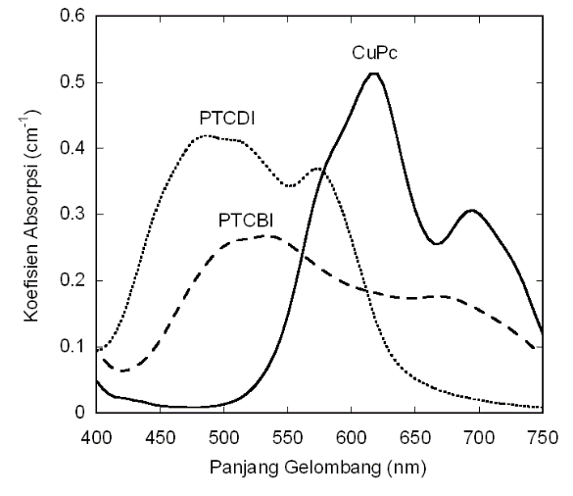
Figure 1. Spectrum koefisien

- Equation (Tnr 10pt)
The equation numbering sequentially ordering, with the equation number written in parentheses and right aligned, for example (1). For writing quantities and variables use Italic Roman symbols. Use a dash (-) to indicate a minus sign. Use parentheses () in the denominator or divisor to avoid confusion. Punctuate the equation when it is in a sentence. For example equation (1):

$f\left(x\right)=a_{0}+\sum_{n=1}^{∞}{\left(a_{n}\cos{\frac{nπx}{L}}+b_{n}\sin{\frac{nπx}{L}}\right)}$ (1)

- RESULT AND ANALYSIST (10 PT)
Contains research data, data processing, data analysis. Data The test results from the tools made or the data from the results of research conducted by the data can be presented in the form of lists (tables), graphs, mathematical equations, photographs or other forms.
Data processing data processing of data obtained using methods that have been determined in the theoretical framework. Analysis of the results obtained in the form of explanations both quantitatively and qualitatively. If it turns out that the analysis is not in line with or deviates from the existing basic theory or the results of testing and measurement, then it must be discussed who causes this. This result is very important for filling out the report sheet.

  - Sub Section 1
Xx

    - Sub Section 2
Yy

- CONCLUSION (10 PT)
Contains various conclusions drawn based on the research that has been done. Is a brief statement about the results summarized from the discussion. Conclusions can be in the form of paragraphs but should be in the form of points using numbering.

REFERENCES (TNR 10pt)
International journals and proceedings are suggested for main references. All references should be to the most up-to-date sources. References format are written in IEEE style and the number of minimum references are 15. see the examples of references bellow (9 pt):
Examples of literature writing from journal writing articles are as follows:
- M. Stemm and R. H. Katz, Measuring and reducing energy consumption of network interfaces in hand-held devices, IEICE Transactions on Communications, vol. E80-B, no. 8, 1997, pp. 1125-1131.
- F. Bennett, D. Clarke, J. B. Evans, A. Hopper, A. Jones and D. Leask, Piconet: Embedded mobile networking, IEEE Personal Communications Magazine, vol. 4, no. 5, 1997, pp. 8-15.
- M. R. Andrews, P. P. Mitra and R. deCarvalho, Tripling the capacity of wireless communication using electromagnetic polarization, Nature, vol. 409, 2001, pp. 316-318.
- S. M. Agarwall and A. Grover, Nucleotide Composition and Amino Acid Usage in AT-Rich Hyperthermophilic Species, The Open Bioinformatics Journal, Vol. 2, 2008, pp. 11-19.

Examples of literature writing from a book article are as follows:
- S. Verdu, Multi-user detection, Cambridge University Press, 1998.

Examples of literature writing from the Seminar Proceedings are as follows:
- L. Clare, G. Pottie and J. Agre, Self-organizing distributed sensor networks, Proceedings SPIE Conference Unattended Ground Sensor Technologies and Applications, vol. 3713, Orlando, April 1999, pp. 229–237.

