**Determination of Service Centre**

**in Parakan Urban Area of Temanggung Regency**

**Reny Yesiana 1*, Khristiana Dwi Astuti 1, Dessy Imawati2, Dhafa Yoga Nurpratama1, Delia Puspita1**

1 Spatial Planning and Land Management, Department of Civil and Planning, Vocational School, Diponegoro University, Indonesia

2 Public Works and Spatial Planning Office Temanggung Regency   
* Email Korespondensi : renyyesiana@live.undip.ac.id

***ABSTRAK***

*The determination of an areas interrelated services is found in urban areas. The spatial structure that will encourage sustainable development in the region is a dynamic process of space utilization change. Parakan District is a sub-district in Temanggung Regency that has been designated as the Parakan Urban Area, to optimize its urban development by determining the determination of service centers. Data methods in the study used primary and secondary data, namely facilities, road infrastructure, trade and services and buildings. The analysis method used to determine the density hierarchy is through kernel density. The final results of the research are density scoring and weighted overlay to determine the service center of the Parakan Urban Area which consists of two villages and eleven villages. The determination of service centers in the Parakan Urban Area is divided into three hierarchies, including city/urban service centers, sub-city/urban service centers and sub-district/village neighborhood centers by considering the existing and estimated development of the area.*

*Kata Kunci: Service Center, Urban Area, Parakan*

**ABSTRAK**

Penentuan pelayanan suatu wilayah yang saling berkaitan terdapat di kawasan perkotaan. Struktur ruang yang akan mendorong pembangunan berkelanjutan di wilayah tersebut merupakan proses perubahan pemanfaatan ruang yang dinamis. Kecamatan Parakan merupakan kecamatan yang terdapat di Kabupaten Temanggung yang sudah ditetapkan sebagai Kawasan Perkotaan Parakan, untuk mengoptimalkan perkembangan perkotaannya dengan melakukan penentuan penentuan pusat pelayanan. Metode data pada penelitian mengggunakan data primer dan sekunder yaitu sarana, prasarana jalan, perdagangan dan jasa serta bangunan. Metode analisis yang digunakan untuk menentukan Hierarchy kepadatan yaitu melalui *kernel density*. Hasil akhir penelitiaan tersebut dilakukan Scoreing kepadatan dan weighted overlay untuk menentukan pusat pelayanan Kawasan Perkotaan Parakan yang terdiri dari dua kelurahan dan sebelas desa. Penentuan pusat pelayanan di Kawasan Perkotaan Parakan dibagi menjadi tiga Hierarchy antara lain pusat pelayanan kota/kawasan perkotaan, sub pusat pelayanan kota/kawasan perkotaan dan pusat lingkungan kecamatan/ desa dengan mempertimbangkan eksisting dan perkiraan perkembangan wilayah.

Kata Kunci: Pusat Pelayanan, Kawasan Perkotaan, Parakan

# INTRODUCTION

The spatial structure based on Law No. 26 of 2007 concerning Spatial Planning is the arrangement of settlement centers and the determination of a network of infrastructure and facilities that serve as a support for the socio-economic activities of the community which hierarchically have a functional relationship (*Undang-Undang Nomor 26 Tahun 2007 Tentang Penataan Ruang*, n.d.). The spatial structure affects the shape of the space, this is due to various networks, especially transportation networks that can determine the direction of urban development and experience a faster increase in economic activity compared to rural areas (Surya, 2015). This is due to the larger urban population and the lifestyle of people in urban areas who are more oriented towards non-agricultural activities (Wang et al., 2023). In addition, the condition of the spatial structure also influences people's behavior patterns, especially on movement patterns because the spatial structure is closely related to the available movement network (Ikhwan, 2010).

One part of the spatial structure is the determination of service centers. The determination of service centers are new centers of activity in an area that will encourage the development of the region, the emergence of activity centers will be followed by an increase in economic activity, utilities, supporting facilities in the socio-economic activities of the community (*Undang-Undang Nomor 26 Tahun 2007 Tentang Penataan Ruang*, n.d.). This determination has a hierarchical and functional relationship that can direct or form the structure and network of service centers in the region, as well as transportation networks and other infrastructure that support service centers. The goal is to form an integrated determination that is able to utilize the potential of the region, so that in the end it can increase the competitiveness of the region (Fasa & Revayanti, 2021).

The existence of service centers is expected to provide more equitable services to urban communities, so it is important to conduct studies on urban service centers (Gao et al., 2017). The determination of service centers in the Parakan Urban Area in this study uses the Kernel Density Estimation method which aims to assist the planning and development of service centers in urban areas. Several similar studies to identify centers of community activity using the kernel desity method with public facility variables in Medan City Urban Area (Lathifah & Aulia, 2024). In addition, the determination of service centers in Pangkalpinang City also uses the kernel density method with variables of health facilities, education, worship, offices, shops, green spaces and road networks (Fitriansyah & Zulkia, 2023). Research on the determination of service centers in the Pattalassang Urban Area is also taken from several analytical studies such as centrality index analysis and kernel density analysis which for kernel density analysis uses facility building point variables and produces the density of each building in the planning area (Hidayat et al., 2022). The research conducted a process of determining service centers in Urban Areas with the same method, namely spatial analysis with the kernel density method which produces a hierarchy through variables of facilities, roads, trade and services and buildings. The difference in determining the research service center in the Parakan Urban Area with the results of several other studies is the existing considerations and estimates of regional development and the scope of the study area taken Parakan Urban Area in Parakan District, Temanggung Regency.

The determination of growth and development of a service center determination needs to pay attention to the spatial structure plan of Temanggung Regency and the development of the city, the distribution of population, activities and existing conditions in Parakan District. Parakan Urban Area is one of the urban areas in Temanggung Regency. In addition, the Parakan Urban Area is one of the Local Activity Center (PKL) areas based on the Regional Regulation of Temanggung Regency Number 1 of 2024 concerning the Regional Spatial Plan of Temanggung Regency for 2024-2044 with the aim of serving district-scale activities or several sub-districts. The determination of service centers aims to increase the effectiveness of services in the study area.

# METHODS

The focus of this research is the Parakan Urban Area with an area of 1,433.93 hectares or 1.65% of the area of Temanggung Regency. The Parakan Urban Area is divided into 2 (two) urban villages and 11 (eleven) villages, namely Parakan Wetan Neighborhood, Parakan Wetan Neighborhood, Traji Village, Wanutengah Village, Caturanom Village, Mandisari Village, Tegalroso Village, Depokharjo Village, Dangkel Village, Campursalam Village, Ringinanom Village, and Watukumpul Village. Parakan Urban Area is located in the geographical position of 7.2508°- 7.3016° N and 110.0901°- 110.0731° East.

The research method for the service center of the Parakan Urban Area is quantitative research compiled with data collection used consisting of two types, namely primary data and secondary data and combining the two. Primary data is data from field observations by collecting data such as the number of facilities, trade and services, as well as road and building infrastructure (Hidayat et al., 2022). Meanwhile, secondary data in this study was obtained through document review and institutional surveys such as statistical data of Parakan Subdistrict, Temanggung Regency RTRW Documents and other documents relevant to development plans and planning in the Temanggung Regency area.

The method of analysis in this study used several methods to determine the hierarchy of areas and service centers. With the analysis carried out including the density of facilities, road density, trade and service density and building density to determine the hierarchy based on its indicators in determining the essence of activity centers and accessibility objects with spatial analysis techniques, namely Kernel Density Estimation density and weighted overlay of the scoring results of each density variable using Arcgis 10.8 software. Kernel density is a processing method based on point or line data that takes into account its density.

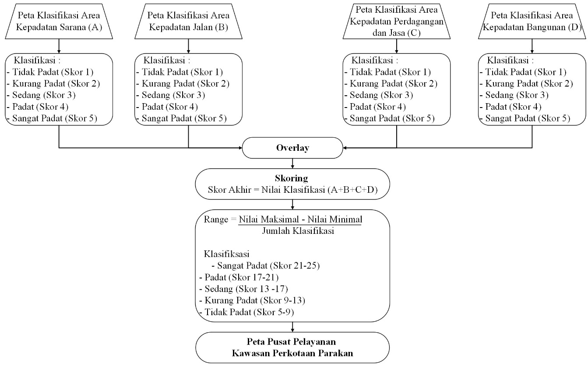

**Figure 1.** Stages of Analysis Kernel Density Estimation (KDE)

*Source: 2024 Compiler*

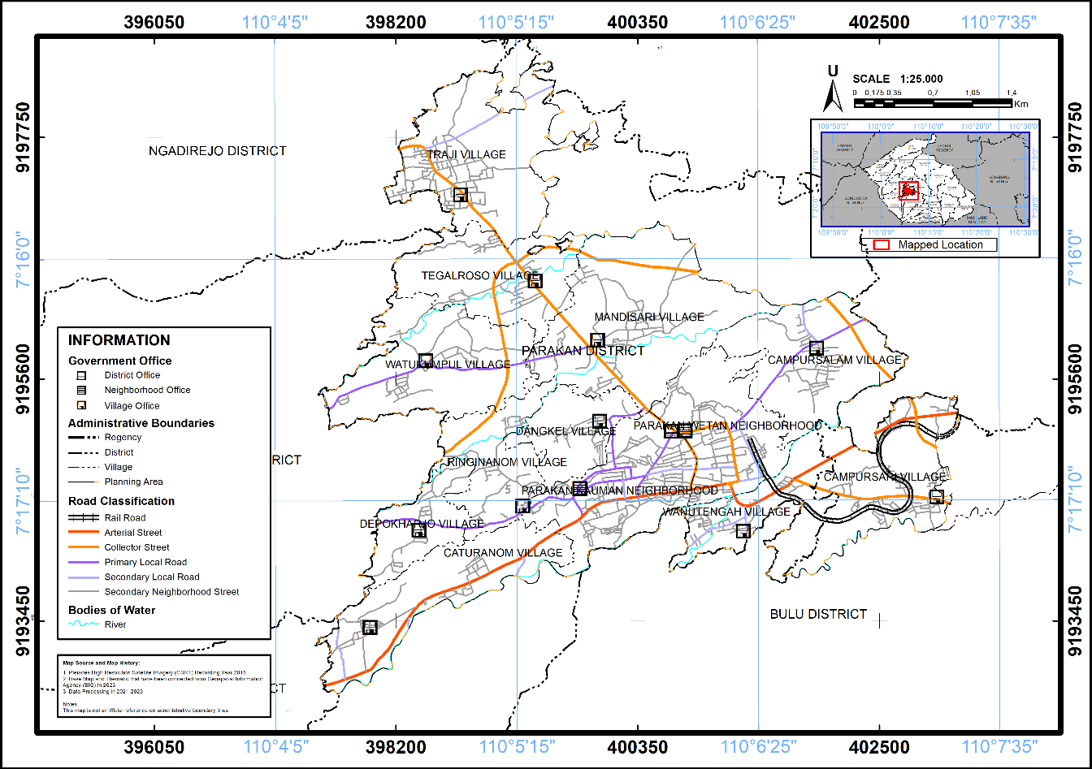

**Figure 2.** Adimistrative Map of Parakan Urban Area

*Source : 2024 Compiler*

# RESULTS AND DISCUSSION

Service center determination analysis is carried out to formulate a hierarchy of service centers in the Planning Area. The preparation of service center determination analysis requires data on the availability of existing facilities. The amount of availability of facilities will affect the hierarchy or level of service centers, the more availability of facilities, the area can become a service center.

1. Density of Facilities

Facility density analysis is conducted to obtain an overview of the level of service of a village/sub-district based on the existence of existing facilities in the Parakan Urban Area. The density of facilities uses data on education facilities, trade and services, government, health, or other public facilities in the Parakan Urban Area. Facilities are services that can fulfill the needs of the community and are affordable for all groups of residents (Rumengan et al., 2019). This kernel density analysis method can show the existence of a concentration of facility density that can serve the needs of the community. The following is a map of the density of facilities in the Parakan Urban Area.

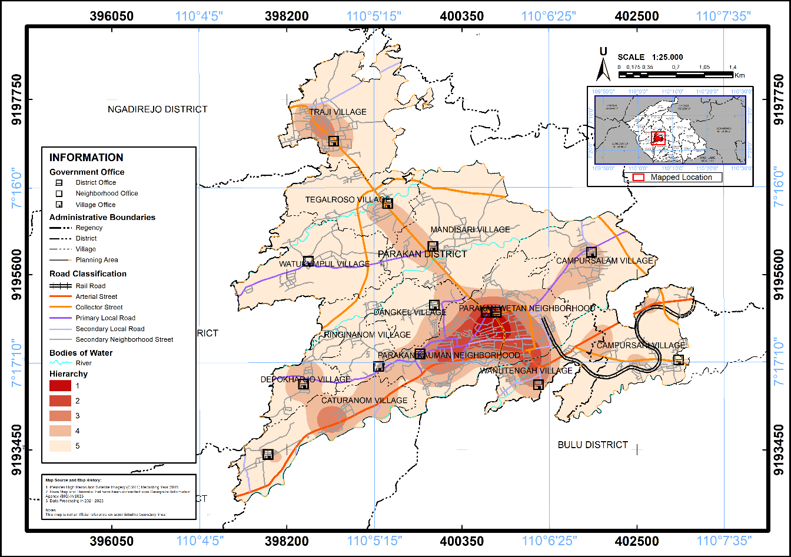

**Figure 3.** Facilities Density Map of Parakan Urban Area

*Source : 2024 Compiler*

The map above shows the value of 1 to 5 which has a different meaning, at hierarchical value 1 means the highest density of facilities which is to determine the service center in the Parakan Urban Area as a service center with facilities that serve the community and are easily accessible by the community in the Parakan Urban Area. Based on the results of the analysis, the resulting interval of each hierarchy is as follows.

**Table 1.** Hierarchy based on Density of Facilities in Parakan Urban Area

|  |  |  |
| --- | --- | --- |
| **Hierarchy** | **Score** | **Neighborhood/ Village** |
| I | 5 | Parakan Kauman |
| II | 4 | Parakan Wetan |
| III | 3 | Wanutengah, Traji, Caturanom |
| IV | 2 | Mandisari, Dangkel, Campursalam, Campursari, Tegalroso, Depokharjo, Ringinanom, Watukumpul |
| V | 1 | - |

*Source : 2024 Compiler*

1. Density of Road

Road network density analysis is carried out to obtain an overview of the level of service of a Village when viewed from the existence of a road network in the Urban Area. The road network is a unity of roads that connects and binds growth centers with areas that are within the influence of their services in a Hierarchys relationship (Fithra, 2017). The kernel density method in road density analysis can help in areas that have good access to main roads that can be used as a consideration to determine strategic locations in building city service centers. The following is a road density map of the Parakan Urban Area.

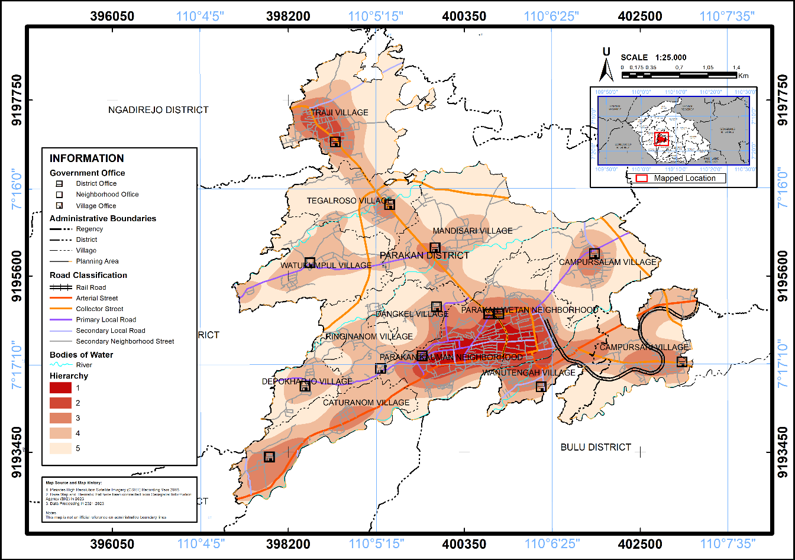

**Figure 4.** Road Density Map of Parakan Urban Area

*Source : 2024 Compiler*

The map above shows areas with different road densities. A Hierarchy 5 value indicates a very high road density which means it has easy road accessibility. Whereas a Hierarchy 1 value indicates low road density. Based on the results of the analysis, the intervals for each Hierarchy are as follows.

**Table 2**. Hierarchy based on Road Density of Parakan Urban Area

| **Hierarchy** | **Score** | **Neighborhood/ Village** |
| --- | --- | --- |
| I | 5 | Parakan Kauman, Parakan Wetan |
| II | 4 | Wanutengah, Traji |
| III | 3 | Caturanom, Mandisari, Dangkel, Campursalam, Campursari, Tegalroso |
| IV | 2 | Depokharjo, Ringinanom, Watukumpul |
| V | 1 | - |

*Source : 2024 Compiler*

1. Density of Trade and Services

Analysis of the density of trade and services is carried out to obtain an overview of the level of service of a Village when viewed from the presence of trade and service facilities in the Urban Area. Based on the position of the Parakan Urban Area in Temanggung Regency as a local activity center, which means that it is the center of the Parakan sub-district and surrounding sub-districts. Then the existence of Pasar Legi Parakan as a city-scale trade and service that makes Parakan Sub-district the center of trade and service activities in Temanggung Regency. The following is a map of the density of trade and services in the Parakan Urban Area.



**Figure 5.** Density Map of Trade and Services in Parakan Urban Area

*Source : 2024 Compiler*

The density of trade and services can be a measure of the location or area as a point or center of the crowd. The trade and service center is a location that can serve the various needs of the community which is located in a central location (Asa Bintang Kapiarsa; et al., 2022). In the Parakan Urban Area, the location of the trade and service center is at Pasar Legi Parakan or other shopping centers that can serve community activities. The map above shows the Hierarchy value which has different meanings, Hierarchy value 1 illustrates the high density of trade and services. Based on the results of the analysis, the intervals of each Hierarchy are as follows.

**Table 3.** Hierarchy based on Density of Trade and Services of Parakan Urban Area

| **Hierarchy** | **Score** | **Neighborhood/ Village** |
| --- | --- | --- |
| I | 5 | Parakan Kauman |
| II | 4 | Parakan Wetan |
| III | 3 | Wanutengah, Traji, Caturanom, Mandisari, Ringinanom |
| IV | 2 | Dangkel, Campursalam, Watukumpul |
| V | 1 | Campursari, Tegalroso, Depokharjo |

*Source : 2024 Compiler*

1. Building Density

The building density analysis was carried out to obtain an overview of the level of service of a villaged seen from the presence of a building facility or built-up area in the Urban Area. This building density is obtained from the results of building locations represented as points in the Parakan Urban Area. Building density is the number of buildings in an area based on the type of building, if the concentration of buildings is denser, it will indicate greater activity and service needs in the area (Setyono et al., 2019). Then, this analysis is carried out by the kernel density method on the building point data in order to produce building density contours with several classifications. The map presents different values to describe the level of building density, ranging from density values 1 to 5. The following is a map of the building density of the Parakan Urban Area.

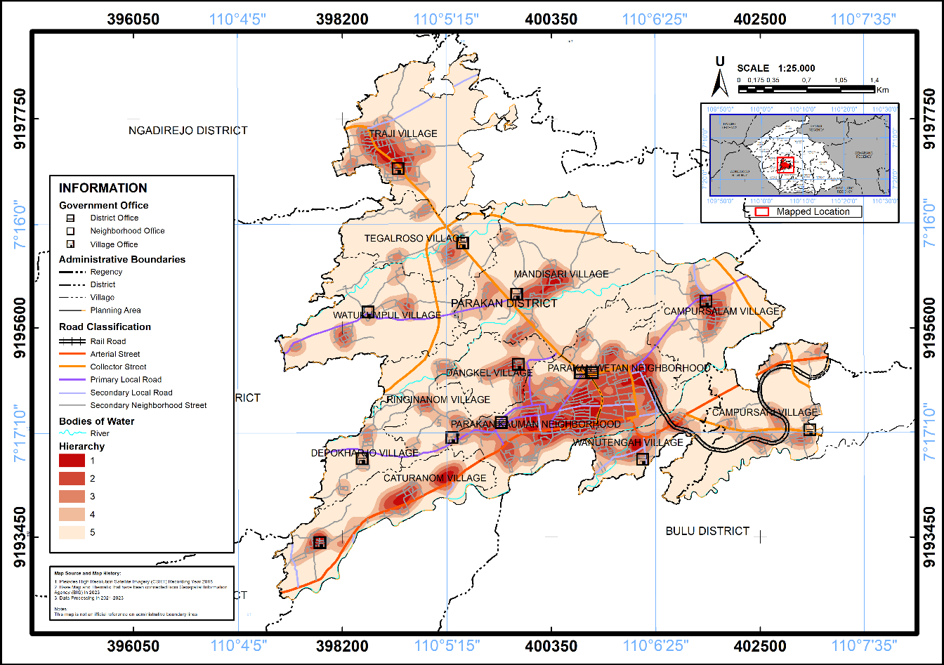

**Figure 6.** Building Density Map of Parakan Urban Area

*Source : 2024 Compiler*

On the map above shows several colors, the red color illustrates that the area has a density value of 1 which means the highest density. While the density that has a value of 5 describes an area with low density. Based on the results of the analysis, the intervals of each Hierarchy are as follows.

**Table 4.** Hierarchy based on Building Density of Parakan Urban Area

|  |  |  |
| --- | --- | --- |
| **Hierarchy** | **Score** | **Neighborhood/ Village** |
| I | 5 | Parakan Kauman, Parakan Wetan |
| II | 4 | Wanutengah, Traji, Caturanom |
| III | 3 | Mandisari, Campursalam, |
| IV | 2 | Campursari, Tegalrejo, Dangkel, Ringinanom, Watukumpul |
| V | 1 | Depokharjo |

*Source : 2024 Compiler*

1. Parakan Urban Area Service Center Plan

Based on the calculation of the analysis of facility density, road density, building density, and trade and service density using the kernel density method to obtain the density level of each variable, calculations can be made to determine the service center in the Parakan Urban Area. The following is the calculation of the results of the analysis of service centers based on the Score in the previous analysis.

**Table 5**. Determination of Service Center of Parakan Urban Area

| **Neighborhood/ Village** | **Facility Score** | **Road Score** | **Trade and Services Score** | **Building Score** | **Amount** |
| --- | --- | --- | --- | --- | --- |
| Parakan Kauman | 5 | 5 | 5 | 5 | 20 |
| Parakan Wetan | 4 | 5 | 4 | 5 | 18 |
| Traji | 3 | 4 | 3 | 4 | 14 |
| Wanutengah | 3 | 4 | 3 | 4 | 14 |
| Caturanom | 3 | 3 | 3 | 4 | 13 |
| Mandisari | 2 | 3 | 3 | 3 | 11 |
| Campursari | 2 | 3 | 1 | 2 | 8 |
| Tegalroso | 2 | 3 | 1 | 2 | 8 |
| Depokharjo | 2 | 2 | 1 | 1 | 6 |
| Dangkel | 2 | 2 | 2 | 2 | 8 |
| Campursalam | 2 | 3 | 2 | 3 | 10 |
| Ringinanom | 2 | 2 | 3 | 2 | 9 |
| Watukumpul | 2 | 2 | 2 | 2 | 8 |

*Source : 2024 Compiler*

The total scoring obtained from each variable, then the determination of service centers is carried out using weighted overlay. The following is a weighted overlay map of the Parakan Urban Area.

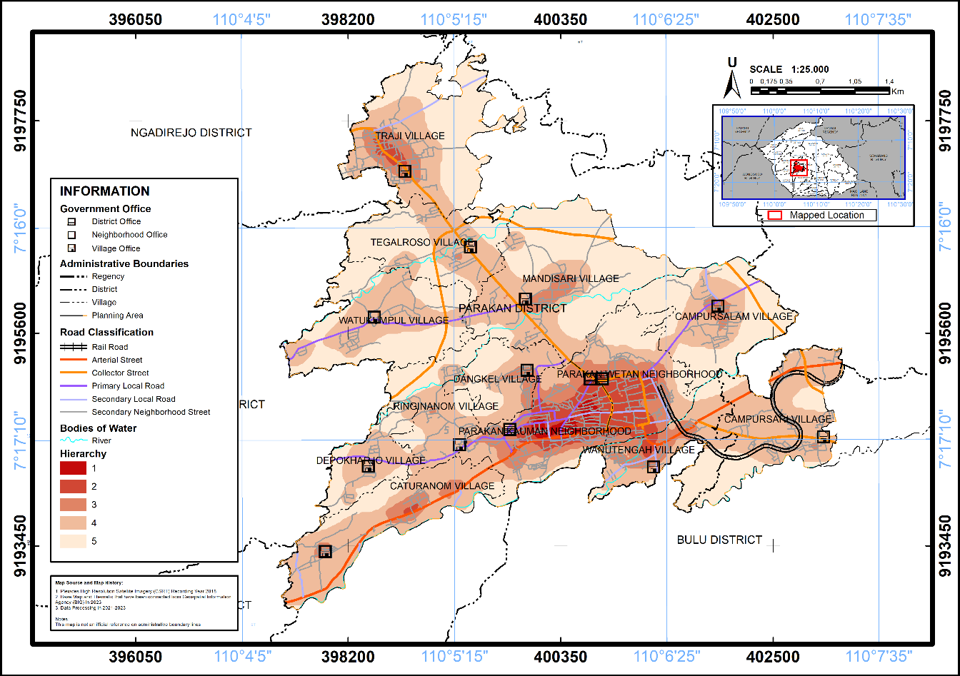

**Figure 7.** Density Map of Service Center of Parakan Urban Area

*Source : 2024 Compiler*

Based on the results of the weighted overlay map above, the resulting Hierarchy of service centers is as follows.

**Table 6**. Hierarchy of Service Centers of Parakan Urban Area

|  |  |
| --- | --- |
| **Hierarchy** | **Neighborhood/ Village** |
| I | Parakan Kauman |
| II | Parakan Wetan, Wanutengah, Traji, Caturanom |
| III | Mandisari, Campursalam |
| IV | Campursari, Ringinanom, Watukumpul |
| V | Dangkel, Tegalroso, Depokharjo |

*Source : 2024 Compiler*

The following is a map of the service center of the Parakan Urban Area in accordance with the Hierarchy table of service centers above.

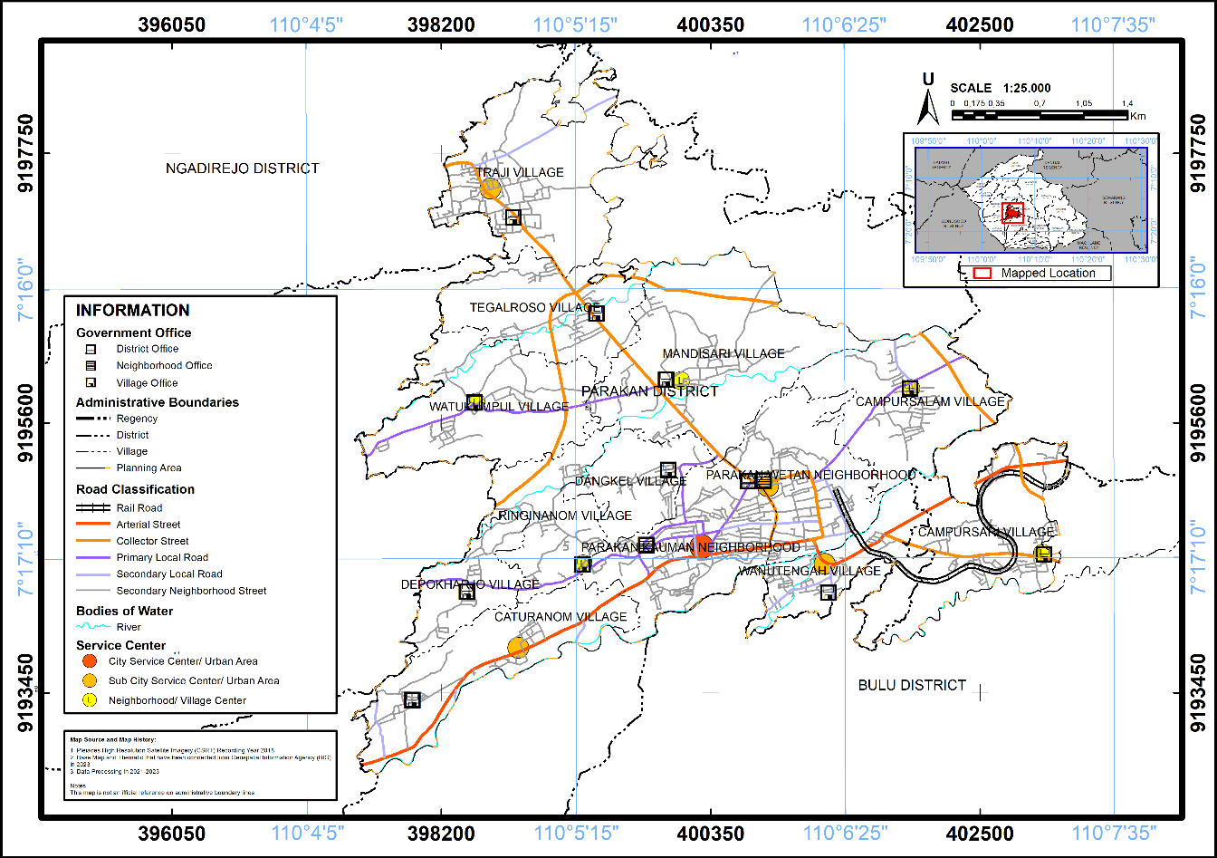

**Figure 8.** Peta Pusat Pelayanan Kawasan Perkotaan Parakan

*Source : 2024 Compiler*

The analysis that has been done through density scoring and weighted overlay, the determination of service centers in the Parakan Urban Area is directed through identification by looking at community activities on existing land use in order to get information related to activities in the Parakan Urban Area as follows.

**Table 7**. Service Center in Parakan Urban Area

| **Neighborhood/ Village** | **Service Center** | **Existing and Forecast Considerations of Regional Development** | **Service Center Location** |
| --- | --- | --- | --- |
| Parakan Kauman | City Service Center/Urban Area | The existence of a trade and service center at Pasar Legi Parakan and the government center of Parakan Sub-district | Legi Market |
| Parakan Wetan | City/Urban Area Service Sub Centers | Completeness of facilities and trade and services and high building density | Parakan Wetan Village Office |
| Traji | City/Urban Area Service Sub Centers | Provincial road access to Ngadirejo sub-district and facilities for the North WP of Parakan Urban Area | Traji Village Office |
| Wanutengah | City/Urban Area Service Sub Centers | The confluence of National and Provincial Roads and Hospitals with trade and service activities. | Ngesti Waluyo Hospital |
| Caturanom | City/Urban Area Service Sub Centers | The existence of industrial facilities and national roads towards Wonosobo Regency which can be planned as trade and service activities | Jami’ Al-Hidayah Mosque |
| Mandisari | Sub-district/Village Neighborhood Center | The density of facilities and buildings is quite high and there is a Provincial Road to Ngadirejo Sub-district | Mandisari Village Intersection (Primary Collector Road) |
| Campursari | Sub-district/Village Neighborhood Center | The density of facilities is rather high and the location is quite far from the City Service Center | Muhammadiyah Hospital Development of people's welfare |
| Tegalroso | Sub-district/Village Neighborhood Center | There is a provincial road to Bulu sub-district and a hospital | Senior High School 1 Parakan |
| Depokharjo | Sub-district/Village Neighborhood Center | Existence of Local Roads to Bansari Sub-district and sufficient density of facilities. | Depokharjo Village Office |
| Dangkel | Sub-district/Village Neighborhood Center | Sufficient density of facilities for a location that is quite far from the City Service Center | Dangkel T-junction (Primary Local Road) |
| Campursalam | Sub-district/Village Neighborhood Center | The existence of a trade and service center at Pasar Legi Parakan and the government center of Parakan Sub-district | Campursalam Village Office |
| Ringinanom | Sub-district/Village Neighborhood Center | Completeness of facilities and trade and services and high building density | MIN Ringinanom |
| Watukumpul | Sub-district/Village Neighborhood Center | Provincial road access to Ngadirejo sub-district and facilities for the North WP of Parakan Urban Area | Watukumpul Village Office |

*Source : 2024 Compiler*

# CONCLUSIONS

The results of the analysis to determine the service center have been carried out by analyzing the density of facilities, road density, trade and service density, and building density to become a density hierarchy. Then perform density analysis using kernel density. Then, density scoring and weighted overlay are carried out to determine the service center of the Parakan Urban Area which becomes three service centers. At the service center of the city/urban area has the potential for trade and service centers and government centers in Parakan Kauman Neighborhood. Then in the sub service center of the city/urban area has the potential to be developed, namely the completeness of facilities and trade and services, access to provincial roads or the meeting of national and provincial roads, high building density and industrial facilities located in Parakan Wetan Neighborhood, Trajil Village, Wanutengah Village, and Caturanom Village. Meanwhile, the sub-district/village environmental center has the potential for residential areas by looking at the density of facilities and buildings found in Mandisari Village, Campursalam Village, Ringinanom Village, and Watukumpul Village.

# REFERENCES

Asa Bintang Kapiarsa;, Silitonga, T., Afrianita, Y., Yasin Ramadhan, M. T., & Kurnia Novianty, S. (2022). Kajian Teori Lokasi Christaller Terhadap Jaringan Pelayanan Sarana Perdagangan Di Pulau Karimun Besar. *Jurnal Pelita Kota*, *3*(1), 150–160. https://doi.org/10.51742/pelita.v3i1.469

Fasa, A. S., & Revayanti, I. (2021). Kajian Penentuan Penentuan Pusat Pelayanan Kawasan Perkotaan di Kecamatan Jatinangor. *Geoplanart*, *3*(2), 85. https://doi.org/10.35138/gp.v3i2.347

Fithra, H. (2017). *Konektivitas Jaringan Jalan Dalam Pengembangan Wilayah Di Zona Utara Aceh*. http://repository.unimal.ac.id/3412/1/Buku Konektivitas Jaringan Jalan.pdf

Fitriansyah, H., & Zulkia, D. R. (2023). Penentuan Penentuan Pusat Pelayanan Perkotaan Berdasarkan Data Point of Interest di Kota Pangkalpinang. *Journal of Education, Humaniora and Social Sciences (JEHSS)*, *6*(2), 853–862. https://doi.org/10.34007/jehss.v6i2.1951

Gao, S., Janowicz, K., & Couclelis, H. (2017). Extracting urban functional regions from points of interest and human activities on location-based social networks. *Transactions in GIS*, *21*(3), 446–467. https://doi.org/10.1111/tgis.12289

Hidayat, A., Hijriah;, & Setiowati, N. O. (2022). Penentuan Pusat Pelayanan Perkotaan Patalassang, Kabupaten Takalar. *Compact : Spatial Development Journal*, *1*(2), 42–52. https://doi.org/10.35718/compact.v1i2.793

Ikhwan, H. (2010). Struktur Ruang dan Isu Keberlanjutan Perkotaan di Jabodetabek. *Perencanaan Pembangunan*, 14–21.

Lathifah, D., & Aulia, F. (2024). *Identifikasi Perkembangan Struktur Polisentris Perkotaan Medan Identification of Polycentric Structure Development in Medan Urban Area*. *8*, 122–132.

Rumengan, C. R. M., Kindangen, I. J., & Takumansang, D. E. (2019). Analisis Ketersediaan dan Kebutuhan Fasilitas Sosial Di Kota Kotamobagu. *Jurnal Spasial*, *6*(2), 375–387.

Setyono, D., Hariyani, S., & Haryani, B. (2019). Identifikasi Bentuk Struktur Ruang Kota Batuidentifikasi Bentuk Struktur Ruang Kota Batu. *Tata Kota Dan Daerah*, *11*(2), 85–92. https://doi.org/10.21776/ub.takoda.2019.011.02.5

Surya, B. (2015). The dynamics of spatial structure and spatial pattern changes at the fringe area of Makassar city. *Indonesian Journal of Geography*, *47*(1), 11–19. https://doi.org/10.22146/ijg.6926

*Undang-Undang Nomor 26 Tahun 2007 Tentang Penataan Ruang*. (n.d.). Lembaran Negaran Republik.

Wang, J., Gao, C., Wang, M., & Zhang, Y. (2023). Identification of Urban Functional Areas and Urban Spatial Structure Analysis by Fusing Multi-Source Data Features: A Case Study of Zhengzhou, China. *Sustainability (Switzerland)*, *15*(8). https://doi.org/10.3390/su15086505